**Daily Git**

**Pre Requirements   
By now you should have a fork of the toy problems repo to your account and clone it to your** **local Desktop**

**Please make sure you have a clone before you move on.**

1- From your terminal, Navigate to *the forked repo*.

*cd rbk-toy-problems*

2- copy the link of the remote repo link this:

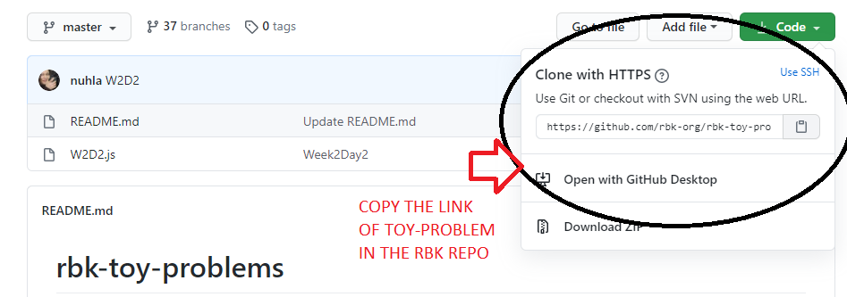

3- Create a new remote locally by running this command in your terminal:

*git remote add TheRemoteName RepoLinkHere (THE ONE YOU COPIED ABOVE)*

Example:c

*git remote add remote https://github.com/rbk-org/rbk-toy-problems.git*

**if you use your own laptop you need to do it once**

**if you used mac machines you need to do it every time you clone the repo**

4. Get the new daily warm-up by pulling it from the remote.

*git pull yourRemoteName master*

*Ex:  
git remote add remote master*

**Note: if you can’t remember your remote name, use the following command to know**

*git remote -v*

5. Read the new warm-up exercise, solve it, and save.

6. Use git status to check the changed files.

*git status*

7. Stage the changes in the file. *git add fileName.js Or “.”*

8. Commit your changes

*git commit -m "yourMessage"*

9. Push your code to your GitHub account

*git push origin master*

10. .share your solution with the administration, from your forked repo in your Github account, select Pull Requests and then click on `create a New pull request.`

Change the `base branch` to `your username`

11. Click Send pull request

12. You are all done